`

SOCIETY OF AUTOMOTIVE ENGINEERS
AERO DESIGN CHALLENGE 2022
DESIGN REPORT OF A RADIO-CONTROLLED HEAVIER-THAN-AIR MODEL AIRCRAFT
TEAM NAME: TEAM GHOST SQUADRON REGULAR CLASS)
TEAM ID: ADC2020101


CONTENTS
Project Title | 1
Statement of Compliance | 2
List Of Figures | 4
List Of Tables | 4
Abstract | 5

Chapter | Title | Page Numbers
1 | Introduction | 5
2 | Design Research | 7
2.1 | Main wing | 7
2.2 | Aerofoil selection | 7
2.3 | Aspect ratio | 10
2.4 | Lift, Drag | 11
2.5 | Power, thrust | 12
2.6 | Flight path angle | 12
2.7 | Take off distance, braking distance | 13
2.8 | Tail volumes | 13
2.9 | Stall velocity | 13
2.10 | Drag and Cl for different angles of attacks | 13
2.11 | Mean aerodynamic chord | 14
2.12 | Mass distribution and CG balancing | 14
2.13 | Horizontal stabiliser | 14
2.14 | Vertical stabiliser | 15
2.15 | Air frame design | 16
2.16 | Servo Sizing | 16
3 | CFD Analysis of Aerofoil | 16
4 | Electrical Systems | 18
5 | Manufacturing | 20
6 | Payload Prediction graph | 22
7 | Conclusions | 23
8 | Final Aircarft 2D Layout | 24
9 | Appendix | 25
10 | References | 28

LIST OF FIGURES
Figure 1: C_{L} vs Alpha (α).
Figure 2 : C_{D} vs Alpha (α).
Figure 3 : C_{L}/C_{D} vs Alpha (α).
Figure 4: C_{L} vs Alpha (α) of FX 63-137.
Figure 5 : C_{D} vs Alpha (α) of FX 63-137.
Figure 6: Pressure Variation Profile on the aerofoil
Figure 7: Power Flow
Figure 8: Selected Electronic Components
Figure 9: Fuselage
Figure 10: Nose Part side view
Figure 11: Nose Part
Figure 12: Left Wing
Figure13 : Wing Span
Figure 14: Tail Part Views
Figure 15: Tail Part Side View
Figure 16: Payload vs Density Altitude graph
Figure 17: 2D Drawing Layout
LIST OF TABLES
Table 1: Drag and C_{L} for different angle of attacks
Table 2: Weight Build-up
Table 3: Aircraft and Fluid data were taken for drag calculations:
Table 4: Selected Electronic components
Table 5: Calculating Payload Fraction

ABSTRACT
Team Ethereal Predators are formed for the annual competition held by the Society of Automotive Engineers- The Aero Design Challenge. The main objective of this competition is to design a lightweight R/C plane (UAV), that is capable of carrying a payload and of meeting the aircraft’s dimensions and power requirements set by SAE. The UAV is designed according to the specifications. The aircraft exhibits required & suitable velocity, lift, drag, payload tolerance, etc. in order to work at the highest efficiency. Special attention has been devoted to retrieving the payload in case of motor failure. The given report is a synopsis of our design process, analysis, substantiation, on and results of our aircraft.

CHAPTER 1: INTRODUCTION
- Project beginnings:
Our team comprises highly motivated aero-enthusiasts with experience in participating in various competitions and tech fests all around the country. In the search for an ideal platform to showcase our interests, we found that the SAE ADC serves as a perfect platform to enhance and exhibit our skills in aero designing and production. Hence, we were encouraged to take part in this significant competition which led to the preparation for our first SAE ADC.
- SAE Aero Design Competition:
SAE has provided three classes for entry: regular, micro, and advanced. Our team has opted for the regular class, the motive of which is to design, substantiate, fabricate, analyze and test an RC plane that is capable of completing a circuit with a payload beyond its weight. The rules and requirements given by the establishment were thoroughly examined while designing the aircraft.
Of all limitations, the most critical we found to be material selection and designing the nose of our aircraft as we focused on retrieving the payload on any possible failure.
Due emphasis was given to the assembly of components such that the vehicle will be simultaneously stable, structurally sound, and most importantly task-effective.
A detailed analysis has been done to choose appropriate parameters or data for designing and then constructing the aircraft.
- Basic Rules to conform with:
1) A maximum time of 2 minutes (120 seconds) will be allowed for a successful take-off.
2) The take-off distance limit is 100ft (30.48m).
3) The landing distance limit is 400 ft (122 m).
4) Fully configured for take-off, the free-standing aircraft shall have a maximum combined length, width, and height of 170 inches.
5) Maximum Wingspan limit is 120 inches.
6) Regular Class aircraft (RCA) may not weigh more than five kilograms (5 kg) and not less than two kilograms (2 kg).
7) The use of Fibre-Reinforced Plastic (FRP) is prohibited on all parts of the aircraft.
8) The use of a 2.4 GHz radio is required for all aircraft competing.
The following procedures and applications were used to design and actuate the aircraft:
- Aerodynamics
- CFD analysis
- Structural design, analysis
- Solid modeling
- Electronics and Radio control
- GENERAL AIRCRAFT DESCRIPTION:
The aircraft designed, is approximately 60 inches long and 92 inches wide with a height of 16 inches. Balsa wood will be used for its construction as per the requirement. It weighs a total of 3750g (predicted) without the payload.

CHAPTER 2: DESIGN RESEARCH
2.1 MAIN WING
The Main Wing is the most important component of all the components involved in the building of an aircraft. It was the first component that was studied and worked upon. The main wing decides the other aspects of the plane like the thrust produced, lift, drag, load-carrying capacity, etc. There are various of wing types that have been studied, those include:
      - Rectangular wing
      - Elliptical wing
      - Tapered wing
      - Delta wing
      - Trapezoidal wing
      - Ogive wing
      - Step tapered wing
Of these 7 types, tapered is the most suitable type of wing design. The drag of this wing type is much lower than the other types. The lift of the tapered wing is comparatively moderate but since the drag is much lower, this deficit in lift is compensated by the low drag and fulfills the requirements. The tapered wing has a longer wingspan, and thus a greater aspect ratio, factors such as maneuverability and stability of the plane are optimized.
The pitch created by the 91.33-inches main wing should be balanced by the tail, so the design of the tail also depends on the design of the main wing and hence is considered and treated as the most important component.
Attaining maximum payload lifting capability, the ability to produce minimum drag and maximum lift at a certain cruise speed, to attain maximum stability, etc are the criterion to be taken into consideration while designing the main wing.

Different variables used and their values:
1 Weight of the plane = 40 N
- Wing span = 92 In
- Chord length = 56 cm (MAC)
- Air density (ρ) = 1.225 Kg/m³
- Velocity (V) = 10 m/sec
- Surface area (S) = 1.28 m² (wing)
Result: Due to the various factors calculated and analysed while comparing the various types of wings, the tapered wing was found to be the most compatible and suitable of all due to its characteristics. The selection of the tapered wing has proved to be right with it’s high lift values providing low drag with good pressure distribution resulting in the frame encountering lesser strain from external factors.
2.2 AEROFOIL SELECTION:
Aerofoil refers to the cross-sectional shape having a design with a curved surface. It’s the cross-section that provides the most favourable ratio between lift and drag in flight. An airfoil is differentiated based on its camber, and so it can be highly cambered, moderately cambered, or symmetrical. The down pitch moment of an airfoil increases with an increase in the camber. Where a higher camber provides greater Cl and Cm, and no camber/symmetry gives zero pitching moment; a moderate camber is the most preferred, as it gives enough lift without much drag.
The aerofoils are selected by iterative method i.e., by comparing two aerofoils at few angles and to check that the coefficient of lift is high and coefficient of drag is low at a particular angle, whichever doesn’t satisfy the above condition, it is replaced by the new aerofoil till we find the required aerofoil that satisfies our conditions and is apt for our purpose.
The aerofoil is selected based on the criteria of coefficient of lift, coefficient of drag, angle of attack, Reynolds number.
α = Angle of attack
C_{L} = coefficient of lift
C_{D} = coefficient of drag
R_{a} = Reynolds number
The Reynolds number shows the type of flow of air leaving the wing, if the Reynolds number is low, it indicates that the flow is laminar and if the Reynolds number is high, then the flow is said to be turbulent. All of the above values change with respect to Reynolds number.
The non-dimensional number for the airflow across an airfoil is given by Reynolds number:
Rn = Speed (miles per hour) X Chord (inch) X K
The speed of the plane is assumed to be 10 meters per second, and the chord length of the main wing is 0.56 meters. Now by calculating we get Reynolds number R_{a} = 3,83,561.6 i.e approximately 3,85,000. But in case let us consider R_{a} = 5 lakhs.
Note:
The flow over the wing is mostly laminar with a range of about 50,000 to 500,000 and becomes turbulent towards the trailing edge. Whereas laminar flow seems desirable as it reduces skin friction drag, and turbulent flow provides an advantage by restricting flow separation.
Since the Rn value was low, an airfoil had to be selected that provided enough lift.
Flow simulations were conducted on XFLR5 on different aerofoils that were selected for comparison, on the basis of graphs between the coefficient of lift vs α, coefficient of drag vs α, and C_{L}/C_{D} vs α. The aerofoil that has the highest lift, lowest drag, and high C_{L}/C_{D} ratio is considered.
After finalizing the camber, some aerofoils which have similar camber were considered such as CH10, Eppler423, FX 74_CL5_140, RG-15, and SELIG 1223.
From the graph below, between the coefficient of lift (C_{L}) and angle of attack(α), shown below SELIG 1223 has the highest coefficient of lift followed by FX 74_CL5_140 and Eppler423 when compared to others.
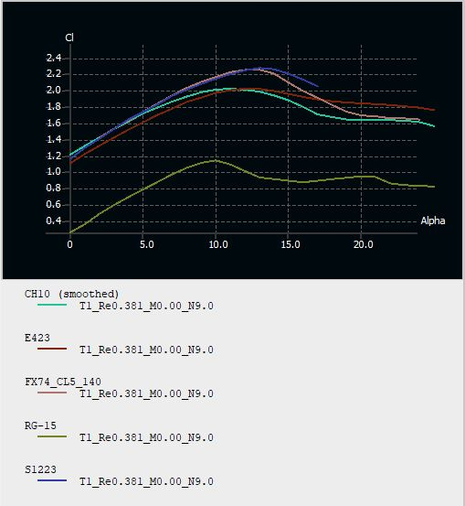

Figure 1: C_{L} vs Alpha (α).
But since we need both, high coefficient of lift and low coefficient of drag, in the next graph we have compared the coefficient of drag and angle of attack, in which Eppler423, FX and SELIG 1223 have almost similarly lower coefficients of drag and followed by CH10 and RG-15.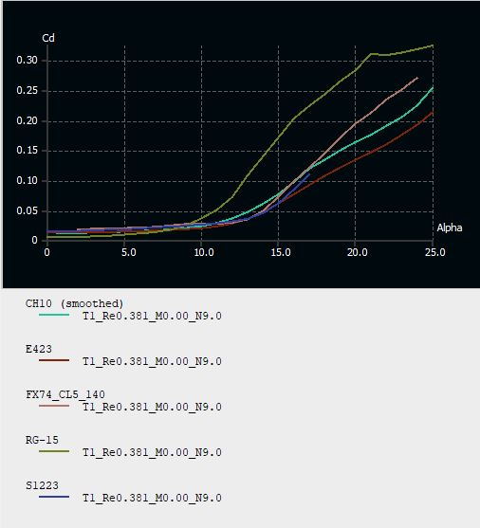
Figure 2 : C_{D} vs Alpha (α).

From the above two comparison graphs, we can observe that SELIG 1223 has the appropriate values for coefficient of lift and coefficient of drag. It can also be observed in the below graph between the C_{L}/C_{D} vs alpha.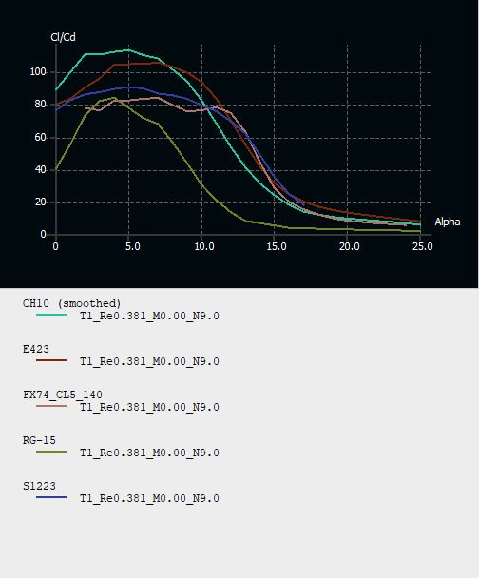
Figure 3 : C_{L}/C_{D} vs Alpha (α).
RESULT:
Considering the above 3 graphs, that are indicating various characteristics of the aerofoils that were used for comparison, show that SELIG 1223 is the most suitable and fulfills the requirements. It’s C_{L} vs α value is among the highest of the compared, the C_{D} vs α value is among the lowest of the compared and the C_{L}/C_{D} vs α is moderate, i.e. almost in between the rest of the aerofoils compared that show the suitability of SELIG 1223.

2.3 Aspect ratio:
The Aspect ratio AR is defined as the ratio between the wingspan and the mean chord length of the main wing which is equal to the square of the wingspan divided by wing area. Both high and low Aspect ratio wings have their own advantages and disadvantages. So, a high AR commonly refers to a higher wingspan.
With an increase in the wingspan, it becomes more difficult to support a wing as the bending moments and torsion effects increase. Moreover, a long wing will be more fragile and vulnerable to aerodynamic flutter.
We have taken wing span of 92 inches and as the taken wing design is tapered, the mean aerodynamic chord is equal to 22 inches.
؞Aspect ratio = 4.22

  - Lift:
Lift depends on the density of the air at the flying height, the square of velocity of the plane, the surface is over which the air flows, and the lift coefficient.
Lift=$\frac{1}{2}ρV^{2}SC_{L}$
Where C_{L} is given by, [C_{L0} + C_{Lα}(α)]. We considered α as 9⁰ as the foil has both lift and drag at suitable conditions at that angle as shown in the below graphs, that are drawn between the coefficient of lift and coefficient of drag and alpha.
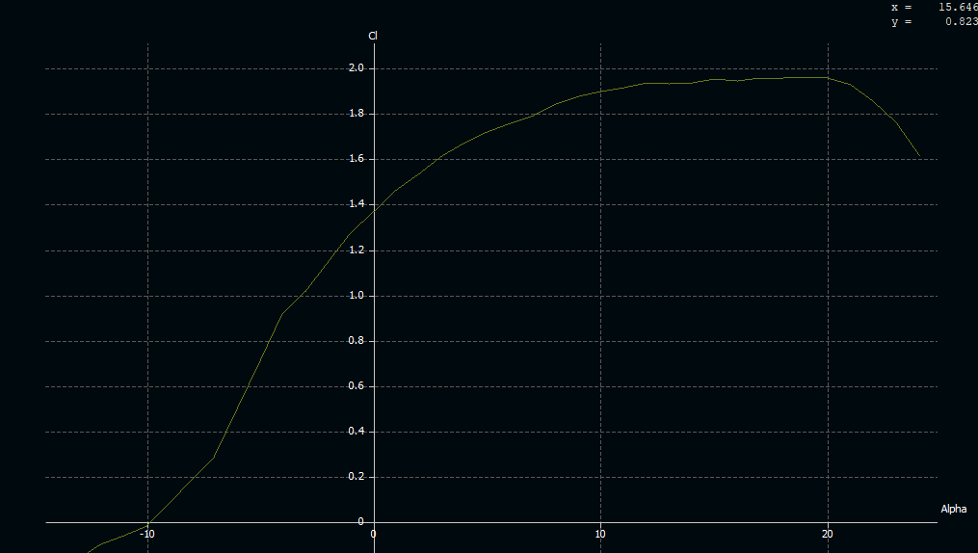
Figure 4: C_{L} vs Alpha (α) of SELIG 1223.
C_{Lα} is the slope of the curve plotted between the coefficient of lift and alpha.
C_{L}=2.15; Lift = 168.56 N
  - Drag:
Drag produced by the wing depends on the density of air at the flying height, square of the velocity of the plane, the reference area, and the drag coefficient.
Drag=$\frac{1}{2}ρV^{2}SC_{D}$.
Where C_{D} is given by [C_{D0} + (C_{L}²/π×AR×e)]. Again, C_{D0} is taken from the graph of coefficient of drag and alpha where α = 0 and C_{L} is taken at α = 6.
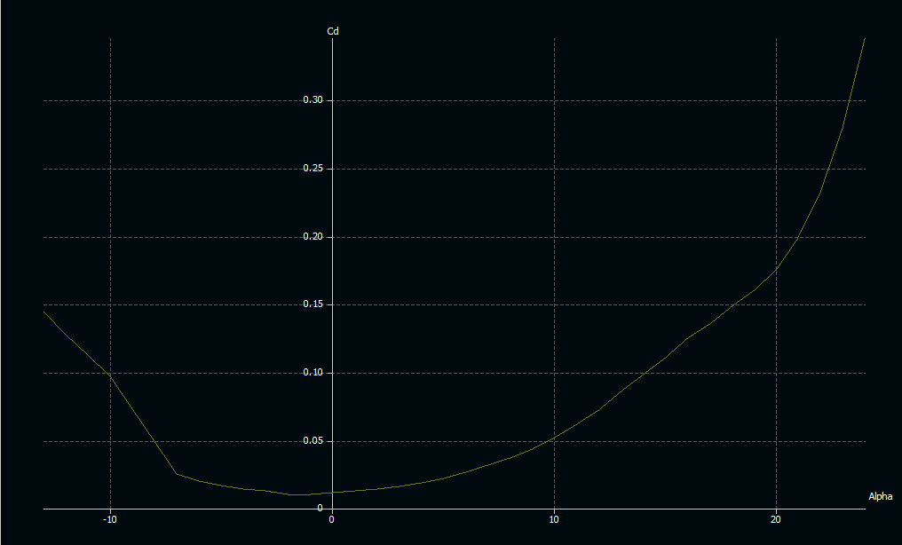
Figure 5 : C_{D} vs Alpha (α) of SELIG 1223.

Hence, C_{D} = 0.46; Drag = 36.06 N

  - Taper ratio:
The taper ratio is one of the parameters of planform geometry. It is the ratio of the root and tip chord lengths of a wing. Therefore, it effects the wing’s aerodynamic parameters and is essential for the design process.
$Taper ratio=\frac{tip chord length}{root chord length}$ ; TR = 0.667
  - Power:
Now we can look at the propulsion system requirements, i.e. power - The power required for maintaining a steady level of the aircraft.
T_{req} = D And P_{req} = T_{req} × V
P =${(\frac{w}{c_{L}})}^{3/2}×\sqrt{(2×\frac{w}{ρs})}×C_{D}$
P = 197.451 W

Thrust:
We know that thrust is equal to the power divided by the velocity. Hence, from the above power equation,
T = P/V
؞ Thrust =19.8 N

  - Flight path angle:
It is defined as the ratio of the inverse sine of the ratio between the difference of thrust, drag and weight of the plane. Let ɣ be the path angle of flight.

Sin(ɣ) = $\frac{T-D}{W}$
ɣ = 4.48⁰

  - Take off distance:
S_{G}= $\frac{1.44\left(\frac{W}{S}\right)}{g×ρ×C_{L}\left[\frac{T}{D}-\frac{D}{W}-µ\left(1-\frac{L}{W}\right)\right]}$
؞ S_{G}= 16.73 m
Braking distance:
S_{B}=$\frac{{1.15}^{2}×W^{2}}{g×ρ×C_{Lmax}\left[D+µ\left(W-L\right)\right]}$
؞S_{B}=

  - Tail volumes:
Tail volume ratio is given as the ratio of the product of the Tail left arm and Tail plain area to the product of wing area and the wing chord
C_{HT}=$\frac{L_{HT}S_{HT}}{C_{W}S_{W}}$ C_{HT}= 0.5
C_{VT}=$\frac{L_{VT}S_{VT}}{b_{W}S_{W}}$ C_{VT}= 0.04

  - Stall velocity:
V_{stall} =$\sqrt{\frac{w}{\left(\frac{1}{2}\right)×ρ×S×C_{Lmax}}}$
V_{stall}= 8.277 m/s

  - Drag and C_{L} for different angle of attacks
Table 1: Drag and C_{L} for different angle of attacks

Angle of attack (α) | Coefficient of lift (C_{L}) | Coefficient of induced drag (C_{ID}) | Coefficient of drag (C_{D}) | Drag
0 | 1.17 | 0..129 | 0.144 | 11.29
1 | 1.3 | 0.159 | 0.174 | 13.64
2 | 142 | 0.19 | 0.206 | 16.15
3 | 1.53 | 0.22 | 0.2375 | 18.62
4 | 1.65 | 0.256 | 0.2745 | 21.52
5 | 1.73 | 0.282 | 0.301 | 23.598
6 | 1.83 | 0.316 | 0.336 | 26.34
7 | 1.935 | 0.353 | 0.375 | 29.4
8 | 2.02 | 0.358 | 0.408 | 31.987
9 | 2.08 | 0.408 | 0.433 | 33.947
10 | 2.14 | 0.432 | 0.458 | 35.907

  - Mean Aerodynamic Chord:

MAC is the chord of an imaginary airfoil that has the same aerodynamic characteristics as the actual airfoil.
This length can be obtained by: MAC (inches) = $\frac{Wing span (inches)}{Aspect ratio}$ = 0.56 meter(s)
2.13 HORIZONTAL STABILIZER:
Horizontal stabilizer, it is located at the left and right sides of the airplane’s tail, a horizontal stabilizer is designed to maintain the airplane’s trim.
To prevent swing in trim the horizontal stabilizer push the air upwards by this it balances the airplane horizontally.

They are simple components that consists of small and thin pieces of material that is used in fuselage. Usually, horizontal stabilizer consists of an airfoil as that of wing rather we can also use flat plates for this.
Horizontal stabilizer creates a vertical force during flight they are extended from sides of tail.

2.14 VERTICAL STABILIZERS:
A vertical stabilizer, often referred to as the 'tail fin,' is fitted to the aircraft's rear. This, along with the horizontal stabilizers, makes up the empennage. The vertical stabilizer is equipped with a movable rudder, which gives the pilots yaw control - the ability to turn the airplane left and right. Some vertical stabilizers are also fitted with trim control, providing the ability to make finer adjustments.
As well as providing yaw control, the vertical stabilizer prevents unwanted yaw from occurring. This can be a particular issue during a banked turn, when adverse yaw would likely be encountered without the control of the vertical stabilizer.

2.15 AIR FRAME DESIGN:
Fuselage is the centre portion of the plane which holds the battery, payload, motor, main wing, tail wing, propeller. Fuselage is designed to retain strength and lift the predicted payload. It is required to have great stability and strength as Balsa wood is to be used. We designed the fuselage in airfoil like shape so that the fuselage provides some amount of lift. The height of the fuselage is taken based on the height of the battery & payload. The length of the fuselage is taken from the propeller to the aft of the plane. Based on the ratio of height to length NACA 0017 airfoil is chosen. Battery is placed under the payload. So that the centre of gravity lies on the same line & it provided good stability. In between rods are fixed to hold. Airfoil is used in fuselage so that it can provide some amount of lift.

2.16 SERVO SIZING
Based on the design of wing, elevator and rudder sizing, testing is performed on the plane while calculating the thrust required with different iterations it is observed that around 3.5 Kgf.cm thrust is required from the servos. Based on these considerations, ES 3001 Analog Servo is choosen which operates at 4.8-6V voltage with a stall torque of range 3.2-4.2 Kgf.cm.

CHAPTER 3: CFD ANALYSIS OF AEROFOIL
The following aircraft data and fluid data were used for the drag calculations:
Table 3 : Aircraft and Fluid data taken for drag calculations:
Standard air density | 1.225kg/m³
Flight velocity | 12m/s
Fuselage width | 9 in
Wing aspect ratio | 5.6
Horizontal tail aspect ratio | 6
Wing span | 67 in
Wing area(S) | 0.6096 m²

Pre-processing: Meshing of the airfoil was done with a tetrahedron mesh of size 2mm at a minimum quality of 0.6. Other values like Jacobian’s were taken care while meshing.
Post-processing: Turbulent flow was considered as the type of flow with an air velocity of 10m/s for the analysis. 250 iterations were done to get the required solution.
Taking into consideration, the requirement of pressure correction, simple scheme method was used.
Validation and Comparison: The calculated values of coefficient of lift and drag from the above analysis:
C_{L}=1.4 C_{D}= 0.1004
Drag= 5.4 N Lift= 66.7 N
The theoretical values of coefficient of drag and lift calculated in aerodynamic section are as given below.
C_{L}= 1.754 C_{D}= 0.15674
Drag= 8.4273 N Lift= 78 N
From the above data it was found that the values were obtained at an accuracy of 85% of theoretical results.
Pressure variation profile: The pressure variation on the aerofoil is as give below:

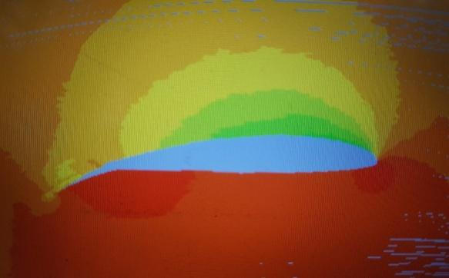
Figure 6: Pressure Variation Profile on the aerofoil
CHAPTER 4: ELECTRONICS
- POWERLOW:

TRASMITTER
RECIEVER
(Channels)
BATTERY
ESC + BEC
BLDC
SERVO MOTORS

Figure 7: Power Flow
Initially, we must select a motor that would provide a thrust in kgs that is more than the load of the plane. Once the motor is selected, propeller must be selected based on the pitch and diameter. Select ESC accordingly based on amps required, and next, the battery on the time of flight required. Lastly, servo motors must be selected to accommodate for the movement of the control surfaces.

SELECTION OF COMPONENTS

    - Motor :Defined in KV. It indicates the RPM per Volt. Higher the KV rating, higher is the RPM. The thrust produced by the motors increases and the RPM per volt decreases as the KV rating decreases. Survey of the market gave us the following options: 2400 KV, 1800 KV, 1200 KV, 840 KV and 630 KV. According to their specifications, as the KV rating was increasing, the thrust produced was decreasing. The 1200 KV motor had an effective thrust of about 2-3 Kgs, which would be enough to propel our plane forward. But the aim of the project is to carry as much payload as possible. The 840 KV motor had an effective thrust of 4-6 Kgs and the 630 KV motor had an effective thrust of 6-8 Kgs. But the 630 KV motor would require a lot more power. So, we had to choose the 840 KV motor.

ESC: ESCs are rated according to maximum current, for example, 35 amperes or 35A. Generally, the higher the rating, the larger and heavier the ESC tends to be which is a factor when calculating mass and balance in airplanes. The type of battery and number of cells connected is an important consideration when choosing a battery eliminator circuit (BEC). The BEC is a part of the ESC. The selected motor, according to its specifications, requires at least 70A. To have a good upper bound, we went with an 80A ESC.

Battery: The selected ESC supports a 2-6s LiPo/ Li ion. The battery we went with is a Orange 5200mah 4S 40C (14.8V) Lithium Polymer Battery Pack (Lipo).

Transmitter and receiver: The transmitter and receiver are usually defined with the number of channels they have. We require one channel for throttle control, one channel for ailerons, one channel for rudder and another channel for elevator. So, in total, we’d need 4 channels. We went for a 6-channel transmitter.

Servo motors: Select at least a servo motor of -60 to +60 degrees.
Table 4 : Selected Electronic components
MOTOR | 840 KV BLDC OUTRUNNER
PROPELLER | MASTER AIRSCREW 11 x 6 inch
ESC | MYSTERY 80 A ESC
BATTERY | ORANGE 5200MAH 4S 40C (14.8V) LITHIUM POLYMER BATTERY PACK (LIPO)
TRANSMITTER AND RECIEVER | FX i6 :6 CHANNELS
SERVO MOTORS | EMAX ES 3001 3.2/4.2 Kgf.cm
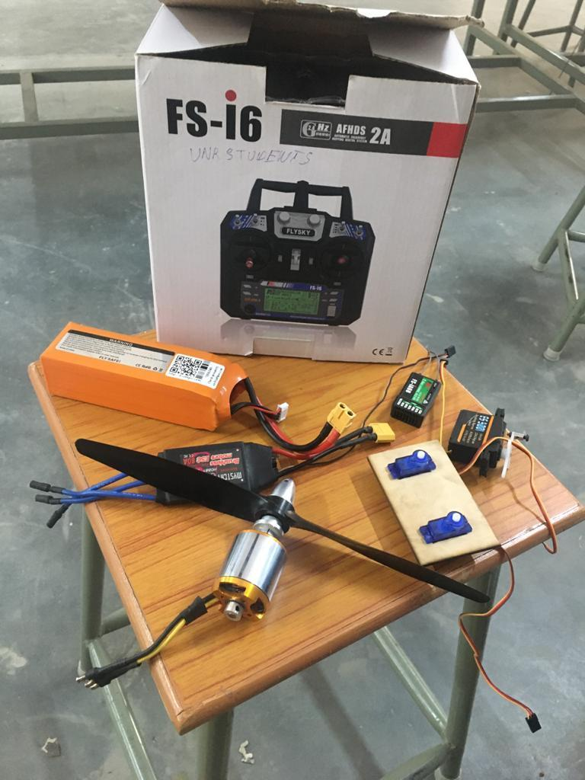
Figure 8: Selected Electronic Components

CHAPTER 6: PAYLOAD PREDICTION GRAPH
Table 5: Calculating Payload Fraction
ABOVE GROUND | TEMPERATURE | P (mm OF Hg) | DENSITY OF AIR | PRESSURE ALTITUDE | DENSITY ALTITUDE | LIFT | PAYLOAD FRACTION
(ft) | (CELCIUS) | P (mm OF Hg) | (kg/m³) | (ft) | (ft) | (N) | PAYLOAD FRACTION
200 | 28.6 | 29.81555 | 1.159908 | 304.45 | 1072.45 | 122.48 | 0.673
400 | 28.2 | 29.61019 | 1.151919 | 710 | 1478 | 121.64 | 0.671
600 | 27.81 | 29.40599 | 1.143975 | 1114.01 | 1976.81 | 120.8 | 0.668
800 | 27.41 | 29.20293 | 1.136075 | 1517.07 | 2427.87 | 119.97 | 0.666
1000 | 27.01 | 29.001 | 1.12822 | 1919 | 2877.8 | 119.14 | 0.664
1200 | 26.62 | 28.8002 | 1.120408 | 2319.8 | 3325.4 | 118.31 | 0.662
1400 | 26.22 | 28.60054 | 1.112641 | 2719.46 | 3773.06 | 117.5 | 0.66
1600 | 25.83 | 28.40199 | 1.104917 | 3118.01 | 4218.41 | 116.68 | 0.657
1800 | 25.43 | 28.20457 | 1.097236 | 3515.43 | 4663.83 | 115.87 | 0.654
2000 | 25.03 | 28.00825 | 1.089599 | 3911.8 | 5108.2 | 115.06 | 0.652

Pressure altitude = (standard pressure - current pressure setting) x 1,000 + field elevation standard pressure=29.92 mm of Hg
density altitude = pressure altitude + [120 x (OAT - ISA Temp)]
Payload Fraction= (Lift-Weight)/Lift
Outside Air Temperature OAT=35⁰ C , International Standard Atmosphere (ISA)
x
Figure 16: Payload vs Density Altitude graph

CHAPTER 7: CONCLUSION
After doing several iterations in the design phase and different methods for analysing and testing we, team Ethereal Predators are confident that our aircraft will fulfill all the objectives of the competition.
With a high lift, higher payload carrying capacity and durable structure this aircraft should represent VNR Vignana Jyothi Institute of Engineering and Technology appropriately.
Though our team lacked the knowledge of some highly utilized analysis tools and resources, such as ANSYS Fluent for fluid simulation, several attempts were made to carry out the wing structure analysis. Building an aircraft with a high payload carrying capacity is the main objective and we believe that this aircraft reflects the hard work and efforts of the team.

CHAPTER 9: APPENDIX
APPENDIX 1: Aerodynamic Characteristics of Cambered Airfoils considered for wing:

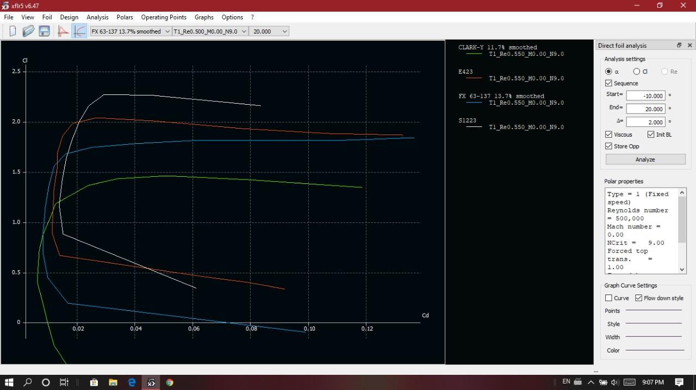

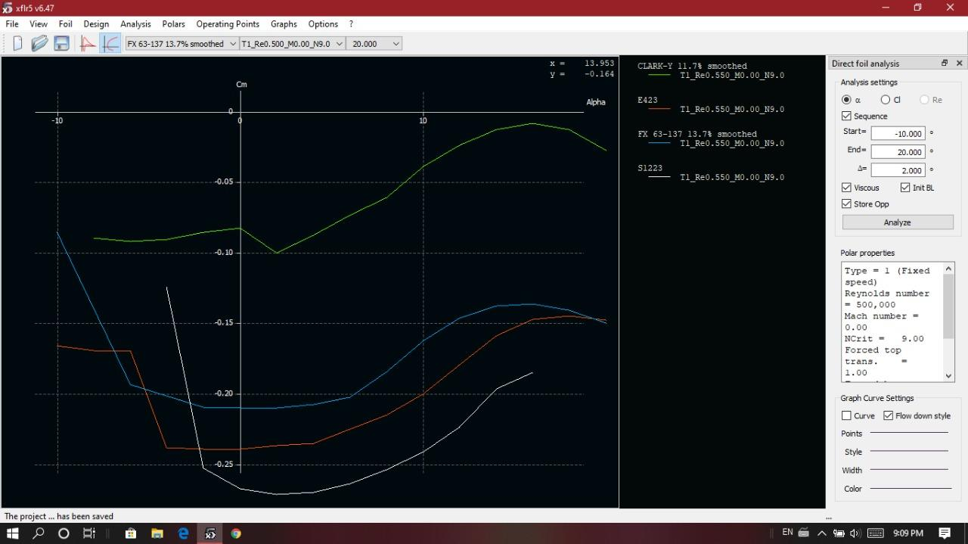

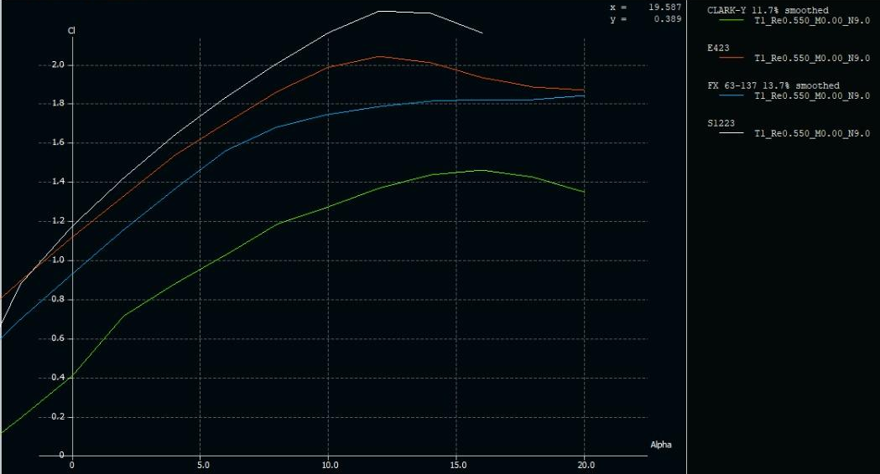

APPENDIX 2: Aerodynamic Characteristics of Zero Cambered Airfoils considered for tail:

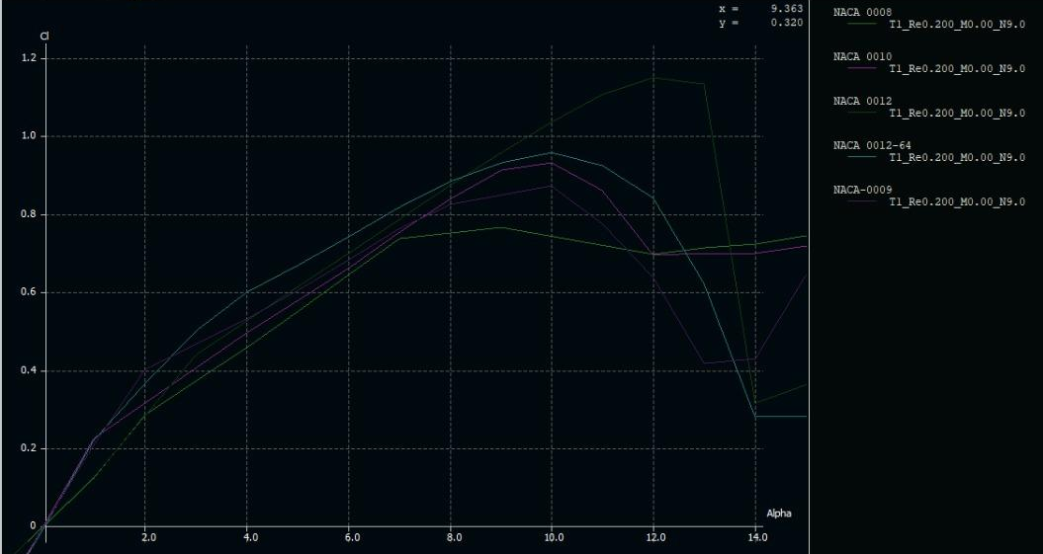
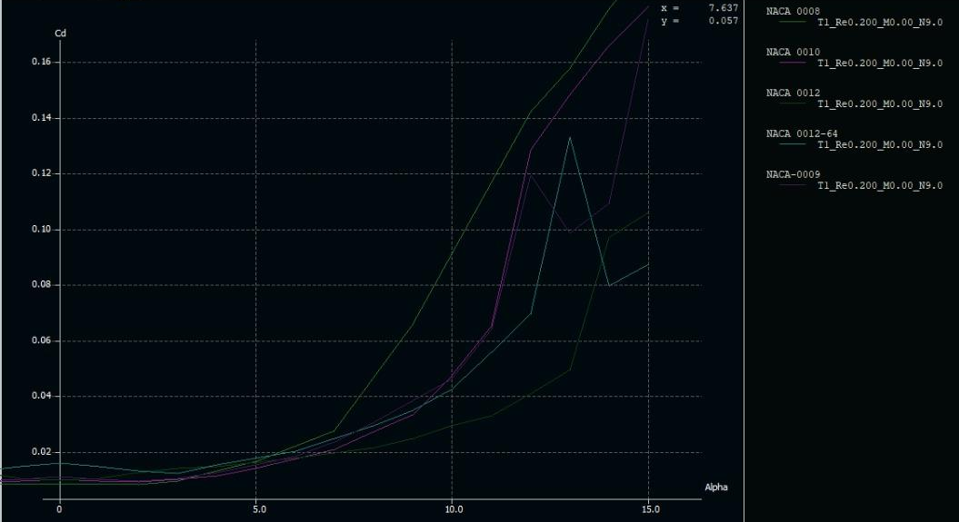
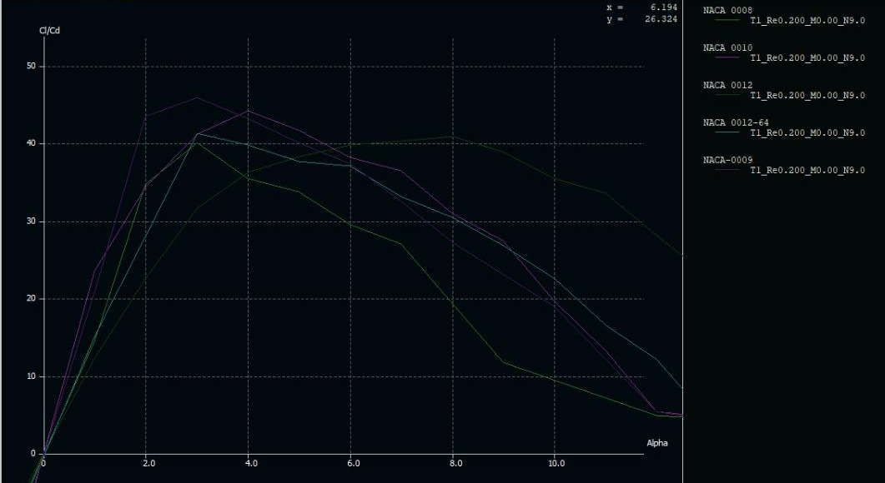
APPENDIX 3: Data for Payload Fraction Determination:

ABOVE GROUND | TEMPERATURE | P (mm OF Hg) | DENSITY OF AIR | PRESSURE ALTITUDE | DENSITY ALTITUDE | LIFT | PAYLOAD FRACTION
(ft) | (CELCIUS) | P (mm OF Hg) | (kg/m³) | (ft) | (ft) | (N) | PAYLOAD FRACTION
200 | 28.6 | 29.81555 | 1.159908 | 304.45 | 1072.45 | 74.71 | 0.598
400 | 28.2 | 29.61019 | 1.151919 | 710 | 1478 | 74.06 | 0.594
600 | 27.81 | 29.40599 | 1.143975 | 1114.01 | 1976.81 | 73.42 | 0.591
800 | 27.41 | 29.20293 | 1.136075 | 1517.07 | 2427.87 | 72.77 | 0.588
1000 | 27.01 | 29.001 | 1.12822 | 1919 | 2877.8 | 72.65 | 0.587
1200 | 26.62 | 28.8002 | 1.120408 | 2319.8 | 3325.4 | 72.13 | 0.584
1400 | 26.22 | 28.60054 | 1.112641 | 2719.46 | 3773.06 | 71.49 | 0.58
1600 | 25.83 | 28.40199 | 1.104917 | 3118.01 | 4218.41 | 70.84 | 0.576
1800 | 25.43 | 28.20457 | 1.097236 | 3515.43 | 4663.83 | 70.2 | 0.572
2000 | 25.03 | 28.00825 | 1.089599 | 3911.8 | 5108.2 | 69.55 | 0.568

CHAPTER 10: REFERENCES
- Watts, Adam C., Vincent G. Ambrosia, and Everett A. Hinkley. "Unmanned aircraft systems in remote sensing and scientific research: Classification and considerations of use." Remote Sensing 4, no. 6 (2012): 1671-1692.
- Raymer, Daniel. Aircraft design: a conceptual approach. American Institute of Aeronautics and Astronautics, Inc., 2012.
- Anderson Jr, John David. Fundamentals of aerodynamics. Tata McGraw-Hill Education, 2010.
- Communier, David, Manuel Flores Salinas, Oscar Carranza Moyao, and Ruxandra M. Botez. "Aero structural modeling of a wing using CATIA V5 and XFLR5 software and experimental validation using the Price-Païdoussis wing tunnel." In AIAA atmospheric flight mechanics conference, p. 2558. 2015.
- Patel, Karna S., Saumil B. Patel, Utsav B. Patel, and Ankit P. Ahuja. "CFD Analysis of an Aerofoil." International Journal of Engineering Research 3, no. 3 (2014): 154-158.
- Steinbuch, Moshe, Baruch Marcus, and Misha Shepshelovich. "Development of uav wingssubsonic designs." In 41st Aerospace Sciences Meeting and Exhibit, p. 603. 2003.

